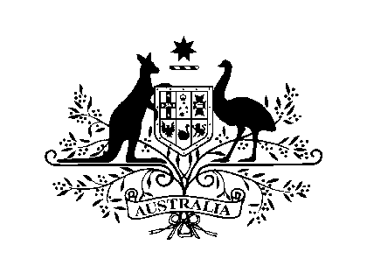

**Funeral Directors**

**The names and contact details of the funeral directors practising in Egypt appearing below has been compiled by the Department of Foreign Affairs and Trade (DFAT) from publicly available information.  DFAT does not endorse any of the funeral directors appearing on this list, provides no guarantees as to its currency and does not accept any liability if you choose to engage one of these funeral directors to provide services.**

# Angels Home (A.H.) Funeral Services

**Address:** 35 Mourad St, Heliopolis, Cairo 11341  
**Tel/Fax:** +2 02 2691-0884

**Mobile:** +2 0122-2743-387 / 0100-3245-959 / +2 0122-2488-794

**General Manger:** Selim Freiha

**Email:** [angelshomeegypt@yahoo.com](mailto:angelshomeegypt@yahoo.com)

# Berlen Giuseppe

**Address (1)**: 241 (A) El Geish St, Cairo

**Address (2):** 29 El Sheikh Kamar St, Dhaher, Cairo

**Tel**: +2 02 2467-1199

**Mobile**: + 2 0122-7383-709 / 0100-1411-538 / 0109-8061-106

**Fax**: +2 02 2482-4806

**Email**: mahaahmed2010@hotmail.com